**Project 6 Coin Detection – Part 2 complete**

Name: Ramya Reddy Period: 4 Date: 3/13/22

Did you name your file l062.cpp (Lower case L, then 062)? Yes

Did you create the edge matrix? Yes

Did you create the gradient direction matrix? Yes

Did you create the imagev.ppm (visual of votes)? Yes

Did you use Bresenham's line algorithm for voting? Yes

Does your application create coins.ppm file? Yes

Does you code display on the screen and in results.txt a summary of your results? Yes

Did you test your code on terminal/gnu linux in c++11? Yes

Run your code (the same code you submit) on the 3 images I provided (easy, medium, hard) then paste here the following:

* The initial image ( the one I provided), the imagev.ppm, coins.ppm you obtained running your code, copy paste here the content of your results.txt file your code created

CLI Argument Key:

-S Number of rows and columns in square grid for voting system

-TC Minimum percentage to be considered a potential circle (in %, not as a decimal)

-MinR Minimum possible radius of circle

-MaxR Maximum possible radius of circle

-MS Minimum separation between centers of two identified circles

1. For the easy image:

Command line including all parameter values used for this image:

--./hello -L 80 -H 150 -F easy.ppm -S 30 -TC 0 -MinR 70 -MaxR 120 -MS 65

Initial image:

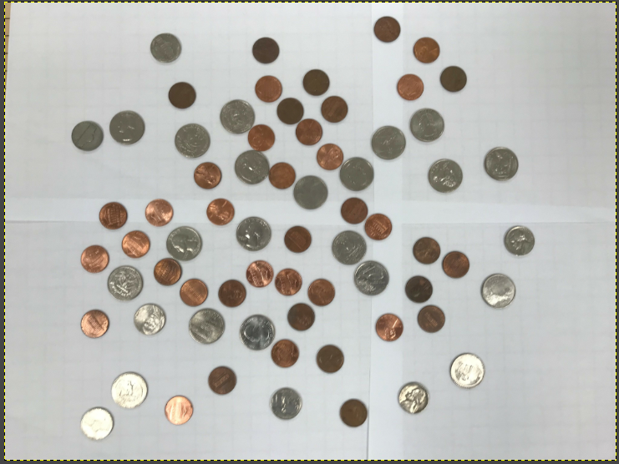

imagev.ppm:

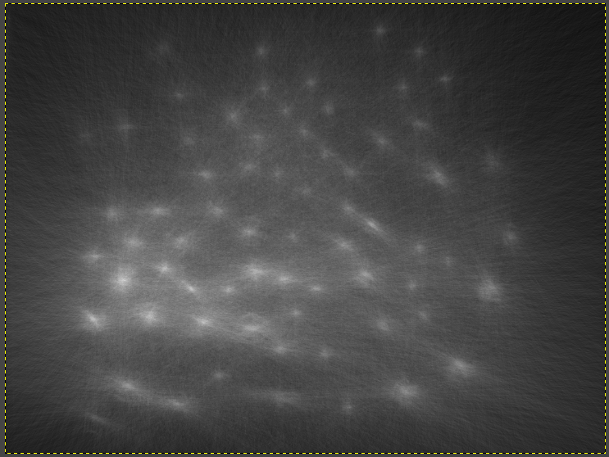

coinsppm:

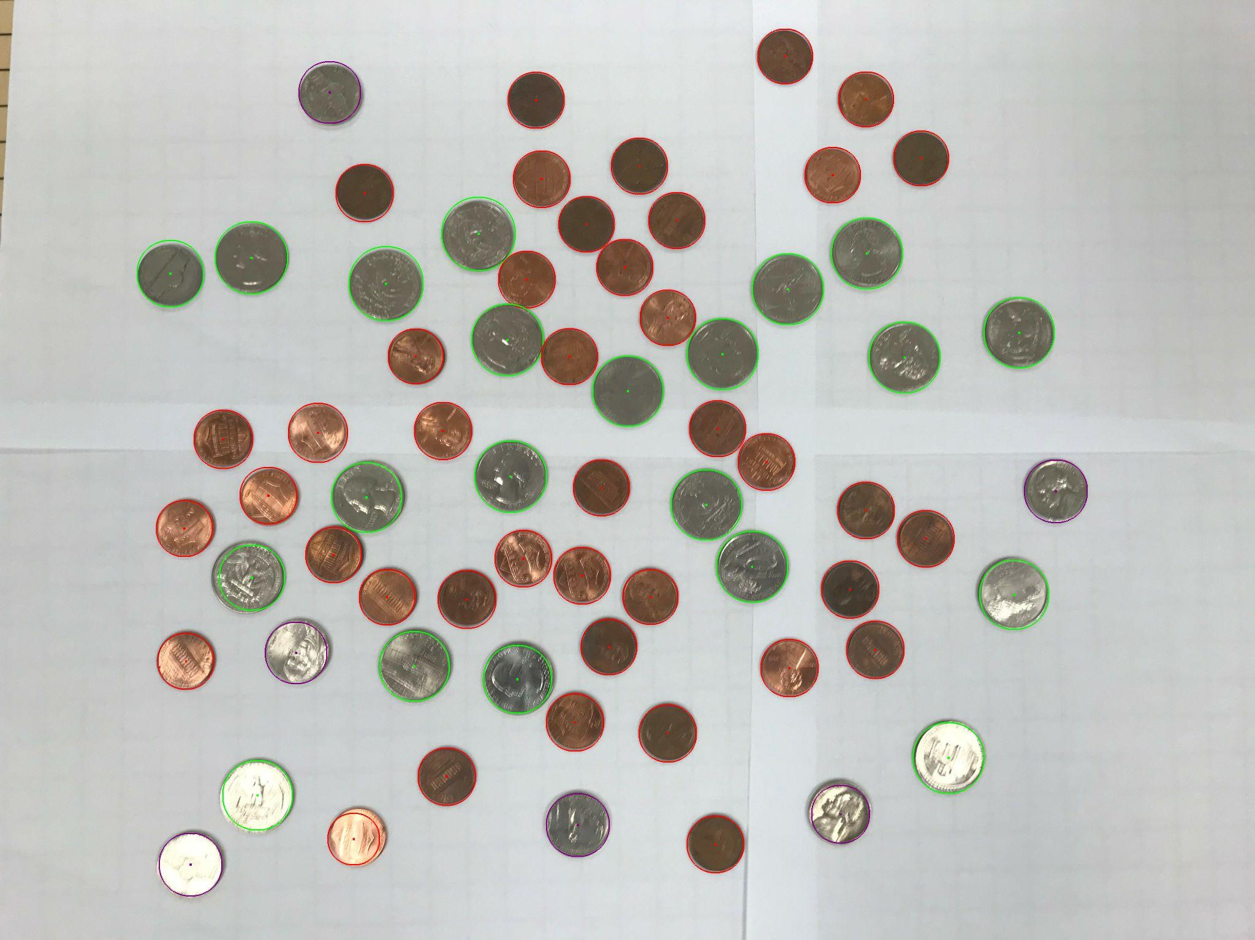

Content of results.txt:

41 Pennies

6 Nickels

0 Dimes

21 Quarters

0 Silver Dollars

Total: $5.96

1. For the medium image:

Command line including all parameter values used for this image:

--./hello -L 80 -H 150 -F medium.ppm -S 30 -TC 0 -MinR 75 -MaxR 120 -MS 54

Initial image:

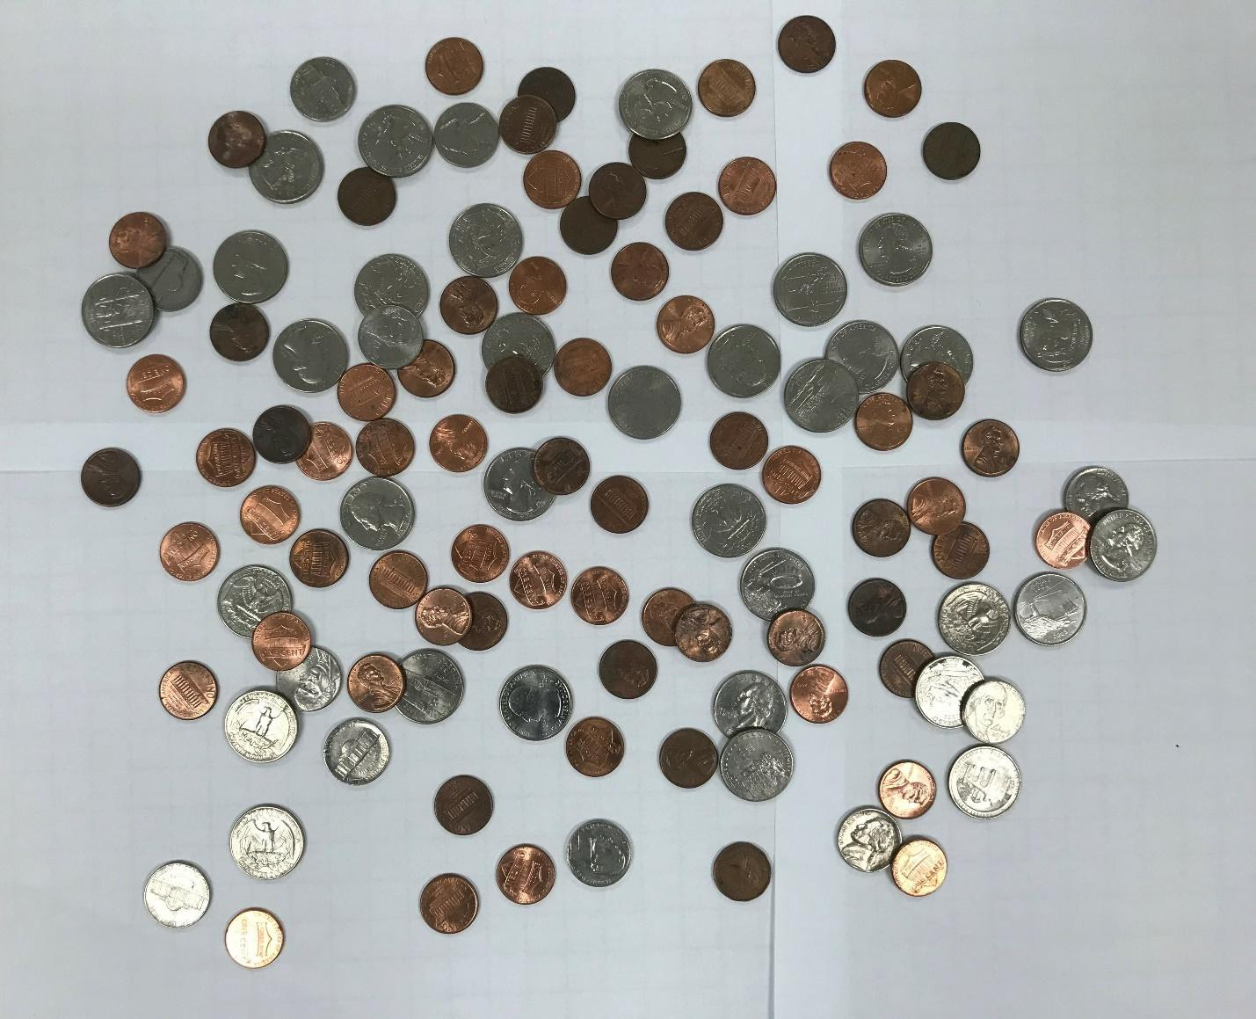

imagev.ppm:

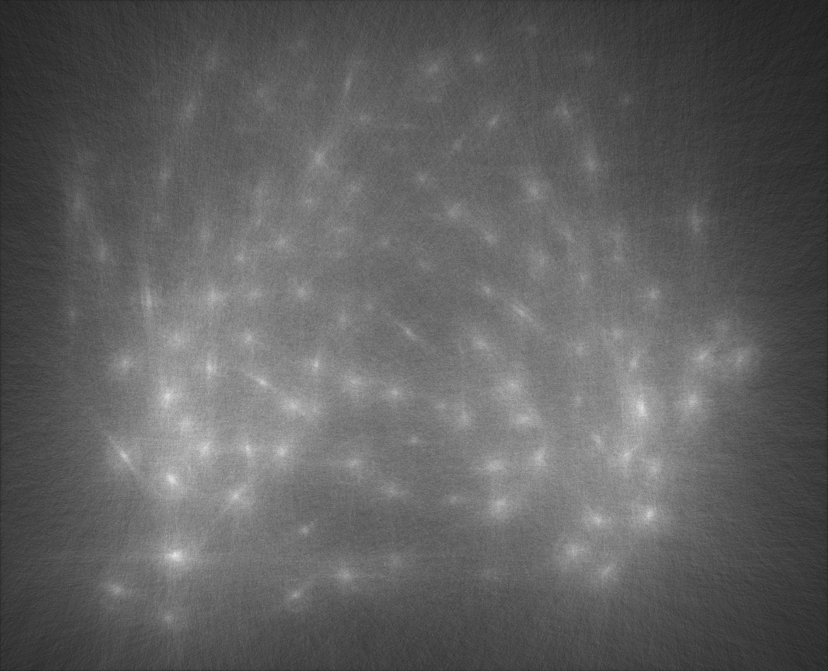

coinsppm:

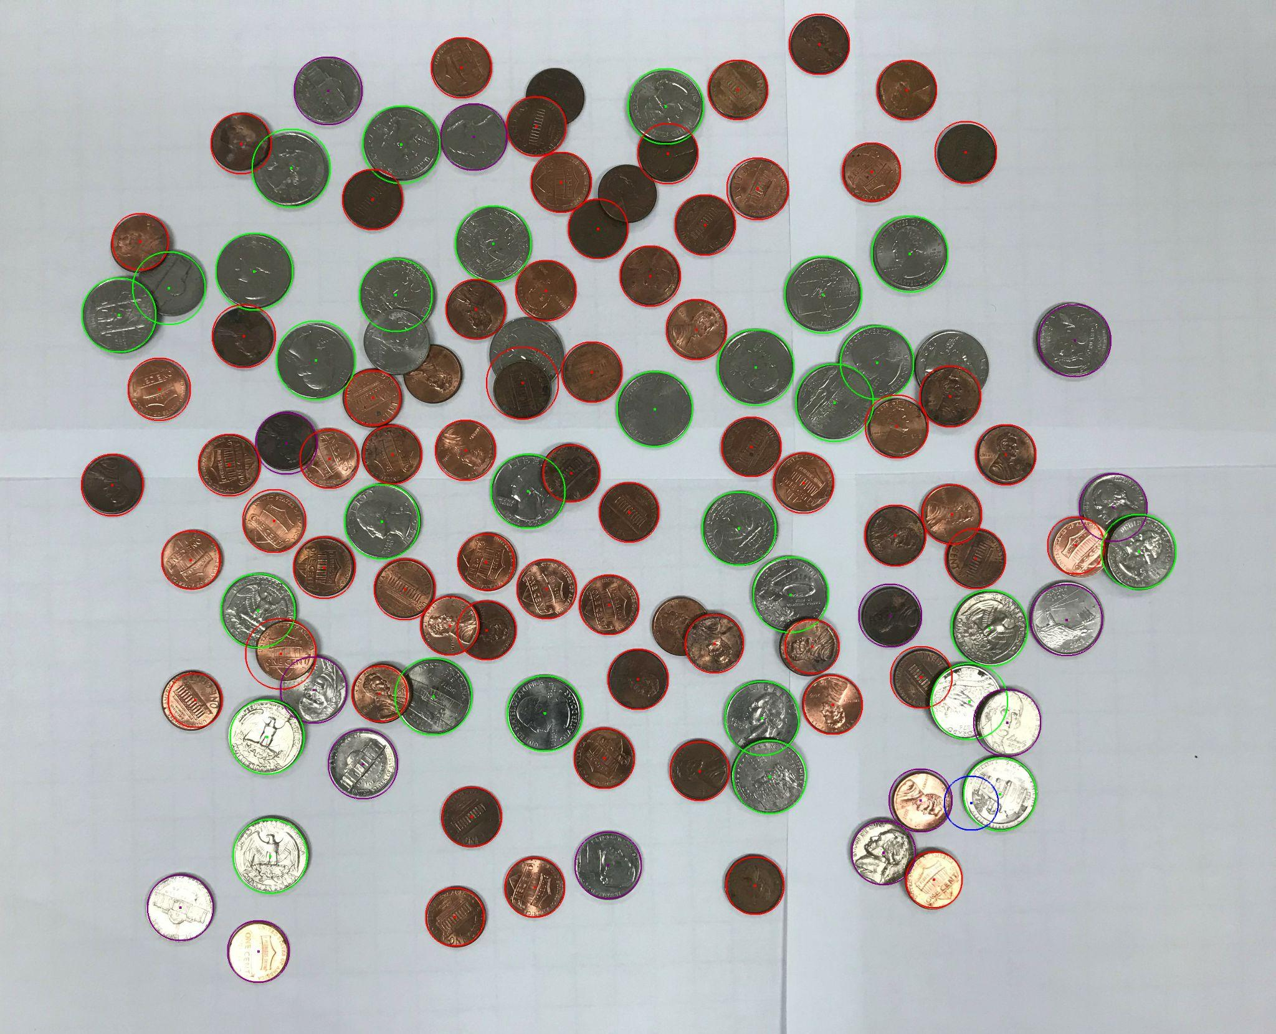

Content of results.txt:

64 Pennies

15 Nickels

1 Dimes

30 Quarters

0 Silver Dollars

Total: $8.99

1. For the hard image

Command line including all parameter values used for this image:

--./hello -L 80 -H 150 -F hard.ppm -S 30 -TC 0 -MinR 70 -MaxR 175 -MS 50

Initial image:

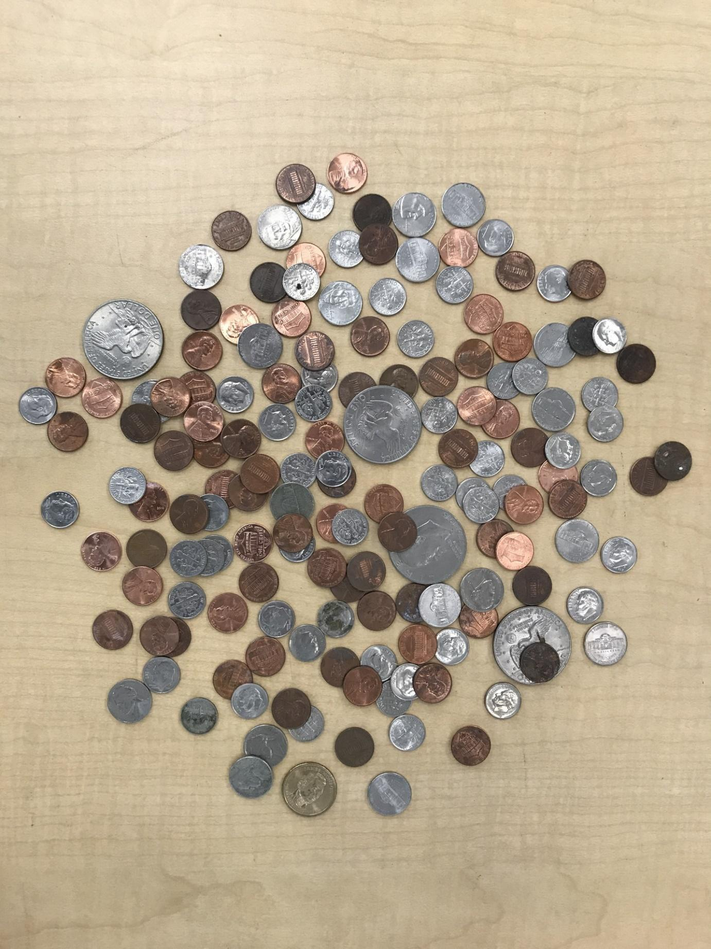

imagev.ppm:

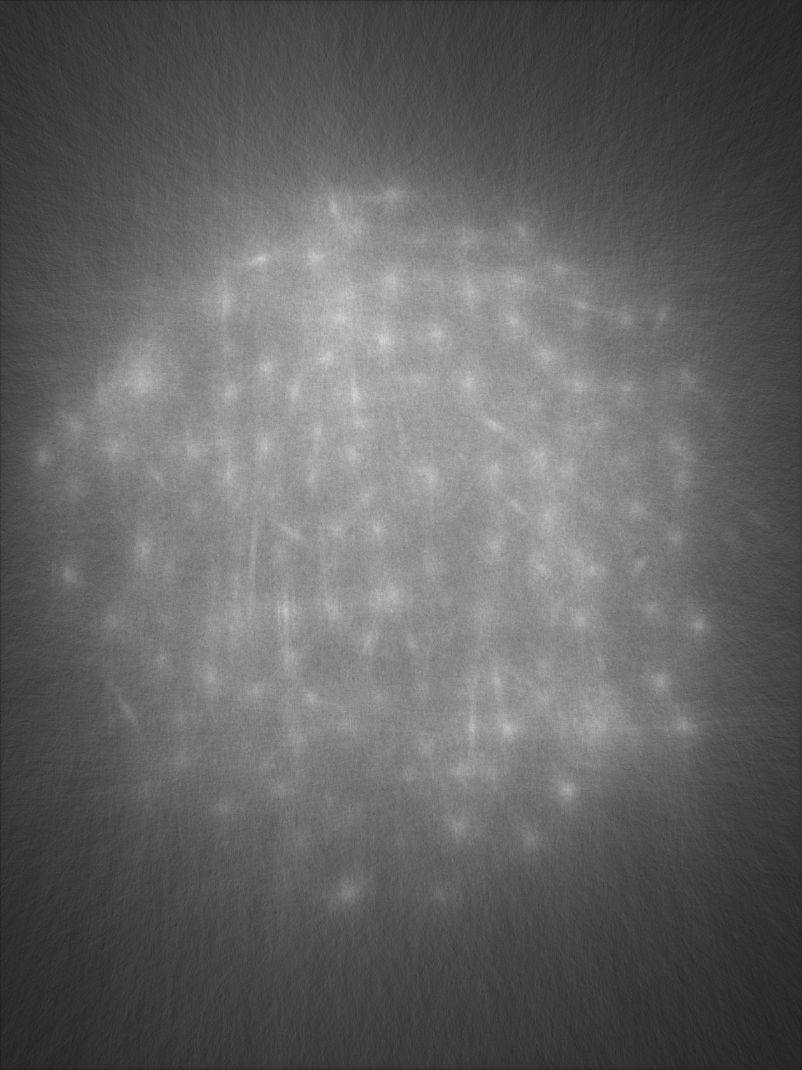

coinsppm

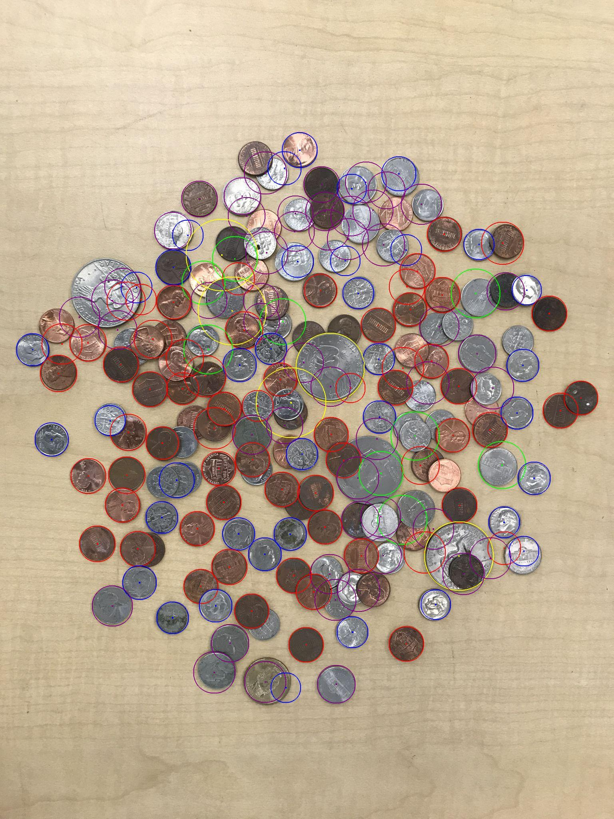

Content of results.txt:

64 Pennies

50 Nickels

37 Dimes

9 Quarters

5 Silver Dollars

Total: $11.59